# SMS Texting Attendance

These instructions assume that you have an active account in CloudCMEâ. If you do not, please set up your account first. You can only record your attendance during the activity or up to 6 days after the meeting. If you miss the window, you may still be able to claim credit in the CE Portal under My CME > Claim Credit.

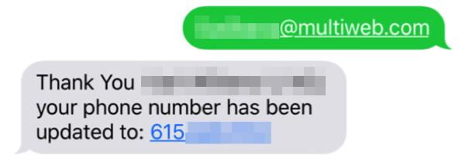

**Step 1**: Pair your mobile phone to your CloudCMEâ account. Text your email address, entered in your Profile, to **(833) 992-1812** to opt-in to the text message attendance program. You will receive a text message that your phone number has been updated. This is a one-time operation.

**Step 2**: To record your attendance to an activity, text the Activity ID or Activity Code that has been provided for your activity[1]. You will receive a text message that verifies activity attendance has been recorded.

**Some Additional Information**

You will receive an incomplete profile text message if you try to text your attendance and have a missing degree and/or profession in your profile. Please complete the fields in your CloudCMEâ profile before texting attendance.

You can only record attendance once for an activity. If you try to record attendance an additional time, you will receive the following text message.

If you attempt to record your attendance at an activity for which you are not registered, you will receive the following text message.

1. **You must text an SMS text message not an iMessage, if using iOS.**